ASSIGNMENT-2

R.RAJARAJESHWARI

SOURCE CODE:

<html lang="en">

<head><style>style.css

* {

box-sizing: border-box;

margin: 0 auto;

}

.container {

width: 1170px;

margin: 0 auto;

}

.row {

display: flex;

}

.head {

justify-content: space-between;

align-items: center;

}

.head p {

font-size: 16px;

font-family: 'Segoe UI', Tahoma, Geneva, Verdana, sans-serif;

font-weight: bold;

padding: 15px 0;

}

.head a {

padding: 0 5px;

color: rgb(109,105,105);

}

.banner{

height: auto;

}

.middle {

position: relative;

background-color: rgb(55,70,196);

width: 100%;

height: 310px;

}

.image {

position: absolute;

width:200px;

height: 250px;

top: 25%;

left: 5%;

border: 5px solid #fff;

display: flex;

}

.image img{

width: 100%;

}

.detail{

position: absolute;

top: 23%;

left: 30%;

font-family: 'Segoe UI', Tahoma, Geneva, Verdana, sans-serif;

}

.detail h1 {

margin: 0;

font-size: 40px;

color: #fff;

}

.detail p{

font-size: 15px;

color: #fff;

}

.btn{

display: flex;

margin-top: 20px;

}

.btn1 button{

padding: 10px 25px;

color: #000;

border: none;

border: #fff;

border-radius: 20px;

margin-right: 10px;

}

.btn2 button{

border-radius: 20px;

padding: 10px 25px;

color: #fff;

background-color: rgb(38,248,226);

border: none;

}

.imfo {

width: 100%;

height: auto;

}

.about {

width: 90%;

margin-top: 25px;

padding-top: 25px;

font-family: 'Segoe UI', Tahoma, Geneva, Verdana, sans-serif;

margin-bottom: 25px;

}

.col-6 {

width: 50%;

}

.left h1{

font-size: 25px;

padding-bottom: 25px;

}

.left p{

line-height: 1.5rem;

}

.right ul li{

padding-bottom: 15px;

list-style: none;

padding-left: 25px;

}

.right ul li span{

width: 30%;

padding-left: 10px;

display: inline-block;

font-weight: bold;

}

.final{

width: 90%;

font-family: 'Segoe UI', Tahoma, Geneva, Verdana, sans-serif;

}

.first {

margin-right: 15px;

}

.second{

margin-left: 15px;

}

.final h1{

font-size: 25px;

padding: 25px 0;

}

.final p{

font-size: 16px;

font-weight: 600;

}

.bar{

width: 100%;

height: 15px;

background-color: rgb(216, 213, 213);

border-radius: 2px;

margin: 10px 0;

}

.percentage{

width: 90%;

height: 15px;

background-color: rgb(73,73,247);

margin: 0

}

.percentage1{

width: 85%;

height: 15px;

background-color: rgb(73, 73, 247);

margin: 0

}

.percentage2{

width: 75%;

height: 15px;

background-color: rgb(73, 73, 247);

margin: 0

}

.percentage4{

width: 75%;

height: 15px;

background-color: rgb(21, 134, 64);

margin: 0

}

.percentage5{

width: 85%;

height: 15px;

background-color: rgb(21, 134, 64);

margin: 0

}

.percentage6{

width: 70%;

height: 15px;

background-color: rgb(21, 134, 64);

margin: 0

}</style>

<meta charset="UTF-8">

<meta http-equiv="X-UA-Compatible" content="IE=edge">

<meta name="viewport" content="width=device-width, initial-scale=1.0">

<title>Resume</title>

<link rel="stylesheet" href="./style.css">

<link rel="stylesheet" href="./fontawesome/css/all.css">

<link rel="stylesheet" href="./style/font-awesome/css/font-awesome.min.css">

</head>

<body>

<div class="nav">

<div class="container">

<div class="row head">

<p>Rajarajeshwari R</p>

<div class="icon">

<a href=""><i class="fab fa-twitter"></i></a>

<a href=""><i class="fab fa-facebook-f"></i></a>

<a href=""><i class="fab fa-instagram"></i></a>

<a href=""><i class="fab fa-github"></i></a>

</div>

</div>

</div>

</div>

<div class="banner">

<div class="container">

<div class="middle">

<div class="row Blue">

<div class="image">

<img src="/storage/emulated/0/Download/images (7).jpeg"alt="">

</div>

<div class="detail">

<h1>Rajarajeshwari R</h1>

<p>Graphic Designer & Web Developer</p>

<div class="btn">

<div class="btn1"><button>Download CV</button></div>

<div class="btn2"><button>Hire Me</button></div>

</div>

</div>

</div>

</div>

</div>

</div>

<div class="info">

<div class="container">

<div class="about">

<div class="row">

<div class="col-6 left">

<h1>About Me</h1>

<p>I'm Rajarajeshwari.I'm possionate about UI/UX design and web I'm skilled front end developer and

master of graphic design tool such as Photoshop and sketch.</p>

</div>

<div class="col-6 right">

<ul>

<li><span>Age</span> 20</li>

<li><span>Email</span> rajiraji5292@gmail.com</li>

<li><span>Phone </span>+0718-111-0011</li>

<li><span>Address</span>245,south Street, Thiruvarur </li>

</ul>

</div>

</div>

</div>

</div>

</div>

<div class="skil">

<div class="container">

<div class="final">

<h1>Professional Skills</h1>

<div class="row">

<div class="col-6 first">

<p>HTML</p>

<div class="bar">

<div class="percentage"></div>

</div>

<p>CSS</p>

<div class="bar">

<div class="percentage1"></div>

</div>

<p>JavaScript</p>

<div class="bar">

<div class="percentage2"></div>

</div>

</div>

<div class="col-6 second">

<p>Adobe Photoshop</p>

<div class="bar">

<div class="percentage4"></div>

</div>

<p>Sketch</p>

<div class="bar">

<div class="percentage5"></div>

</div>

<p>Adobe XD</p>

<div class="bar">

<div class="percentage6"></div>

</div>

</div>

</div>

</div>

</div>

</div>

</section>

</body>

</html>

**INPUT IN VS CODE:** 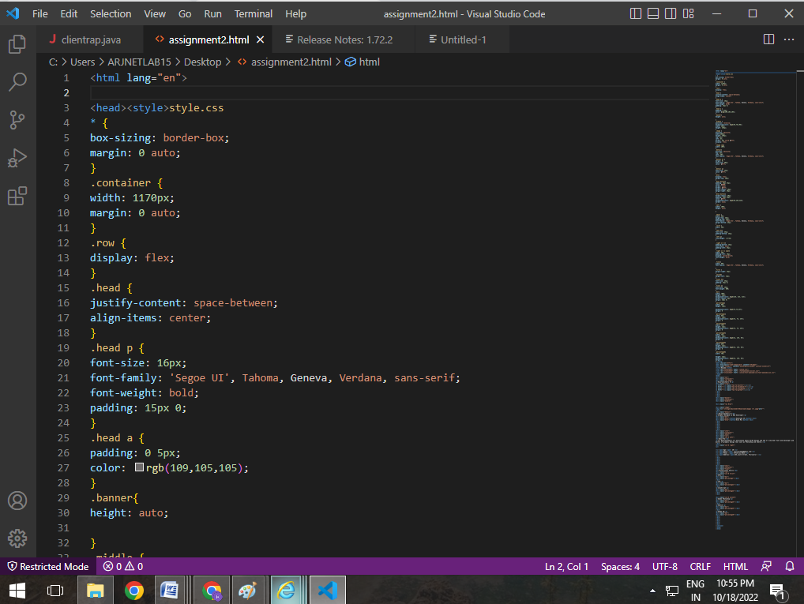

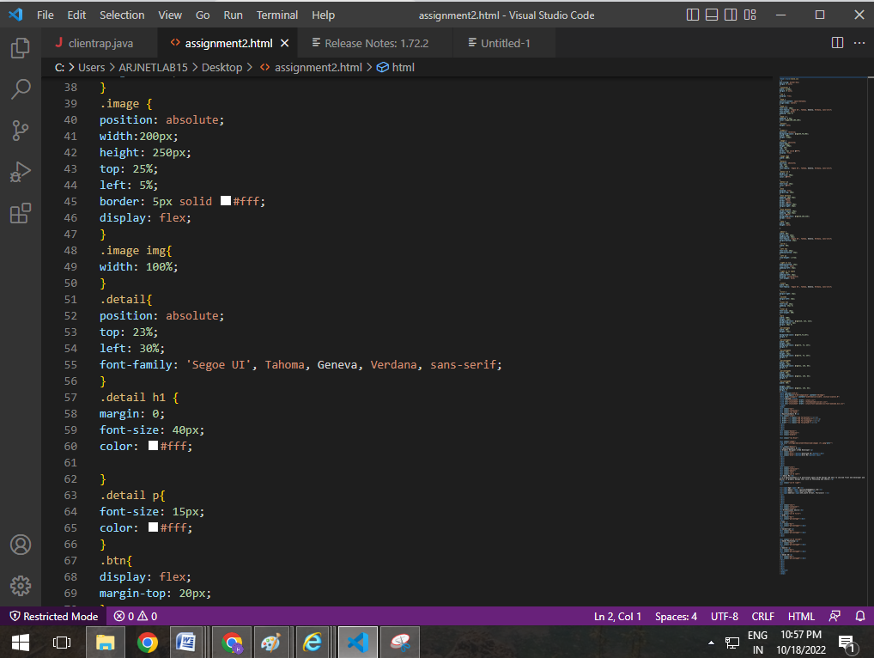

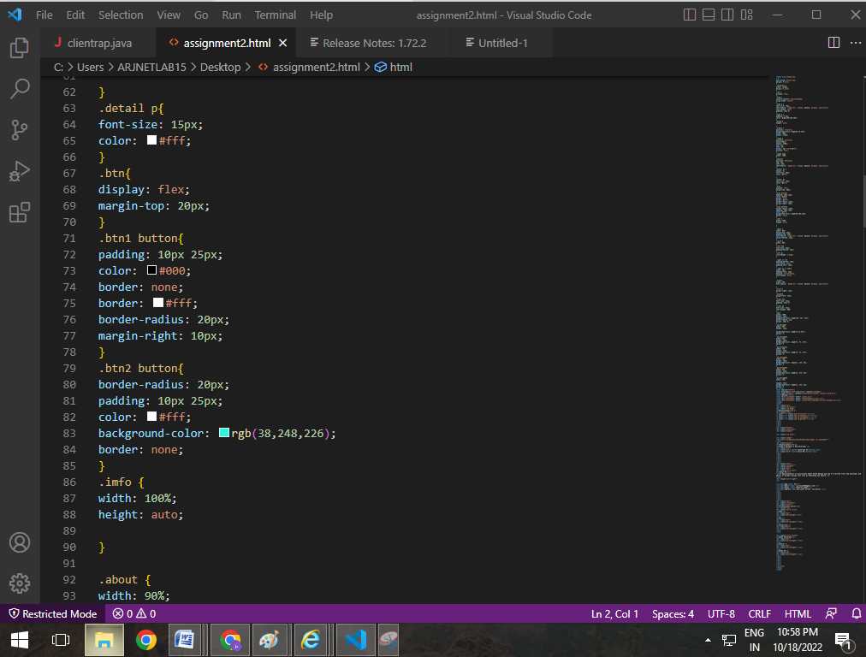

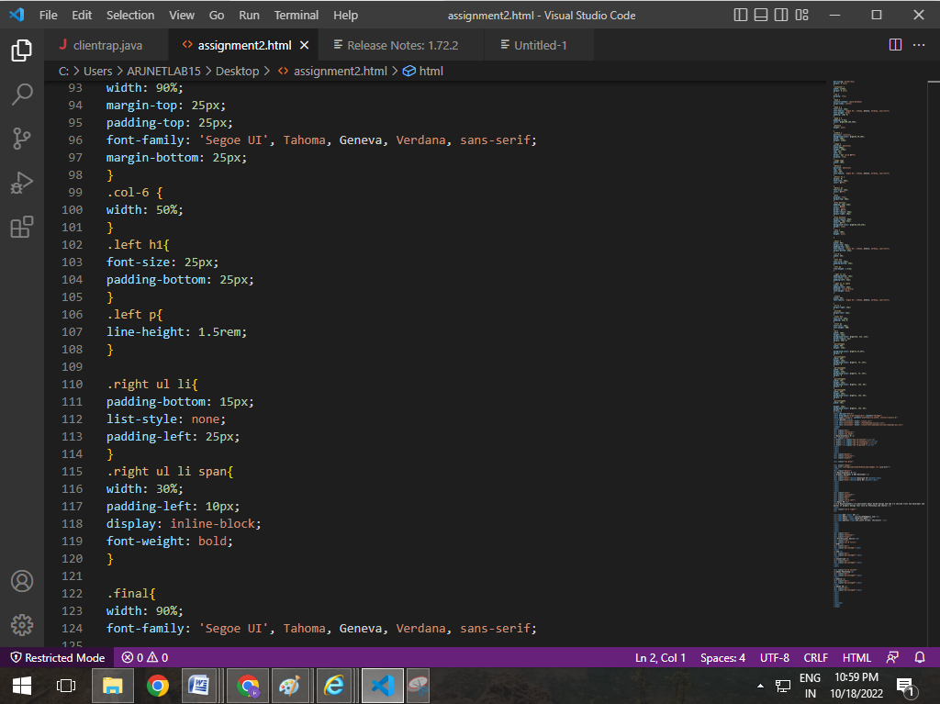

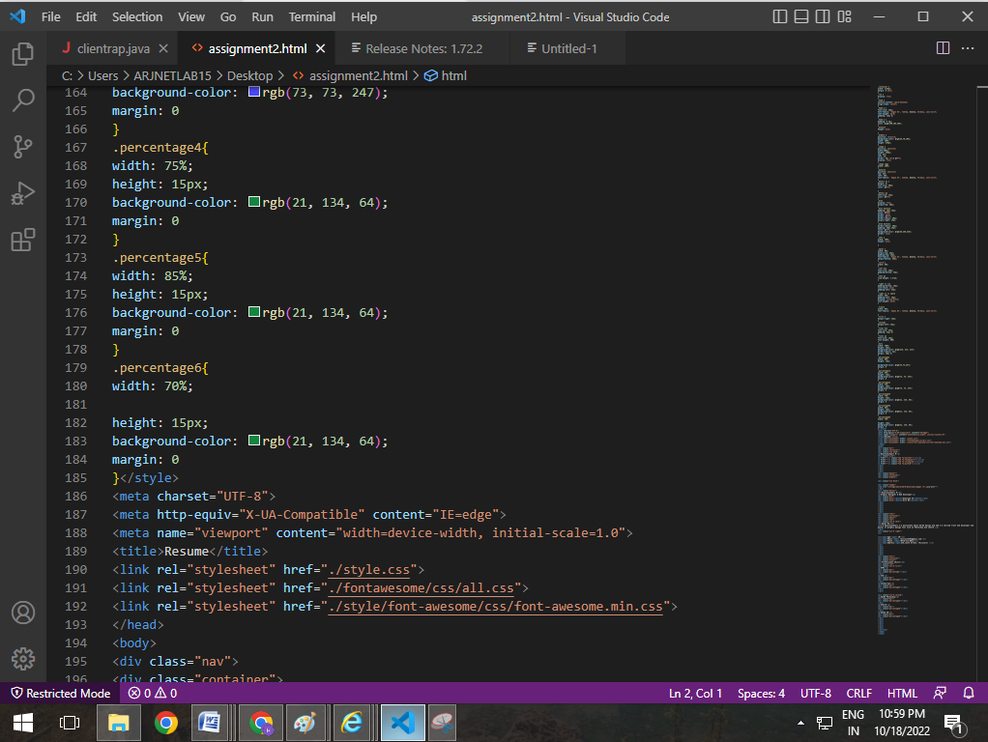

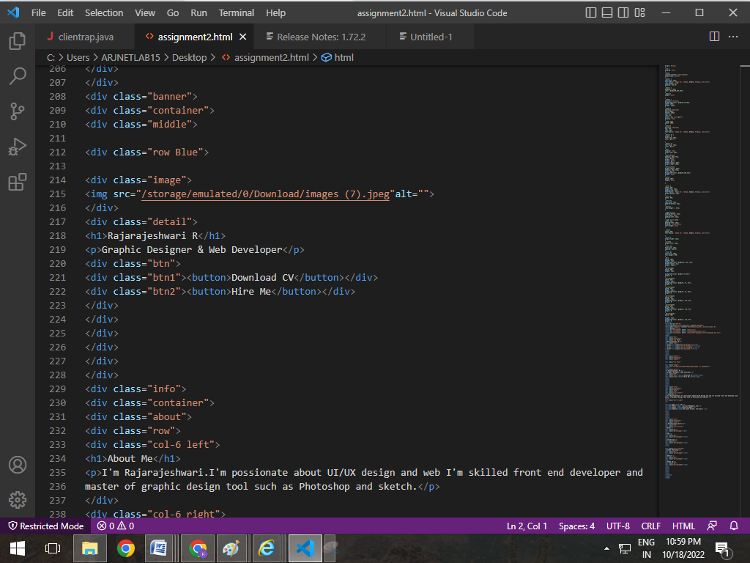

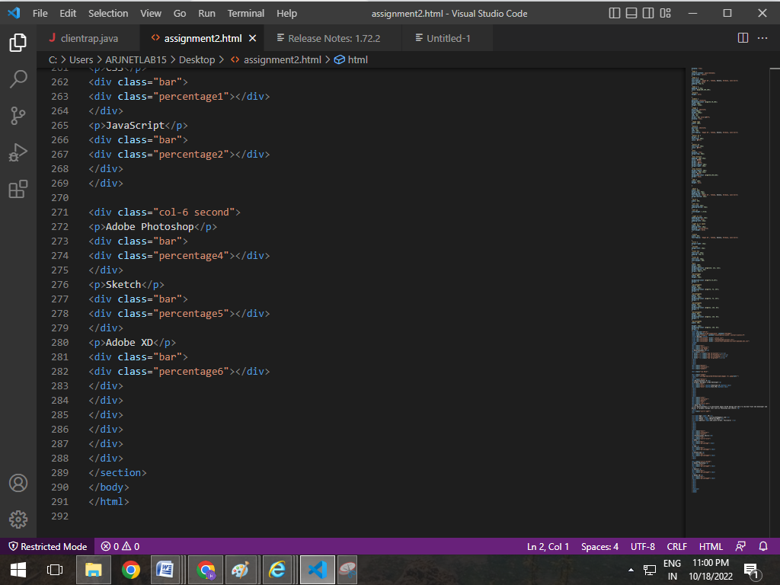

OUTPUT IN VS CODE:

